

Laboratory Report

Course ID: CPS 2390
Lab 2: Problem Solving with the LC-3

Student: Thomas Yamakaitis

Instructor: Dr. Jing-Chiou Liou

Date: 10/19/2016
Description
The objective of this lab was to improve our problem solving skills with LC-3. We had to process data and try to debug the issues with the program.
Procedure and Notes
- I decided to merge my Shift/Rotate Program together. This proved to be difficult, but the way I did it was by using Branches/Flags as a switch. Therefore, my program requires 3 inputs. It requires the bit pattern stored in [x3100], it also requires a counter for n-bits to shift/rotate to the left stored in [x3101], and finally an input of either 0 or not zero stored in [x3102] (if 0, shift by n-bits to the left, if not 0, rotate by n-bits to the left).
- The test data I used is, the bit pattern 0000111100001111, n = 4 bits, and 1 for rotate. The result should be 1111000011110000

Results and Reports
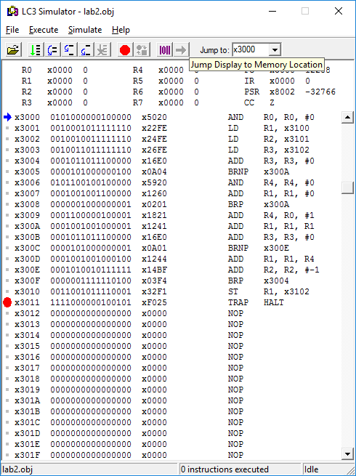
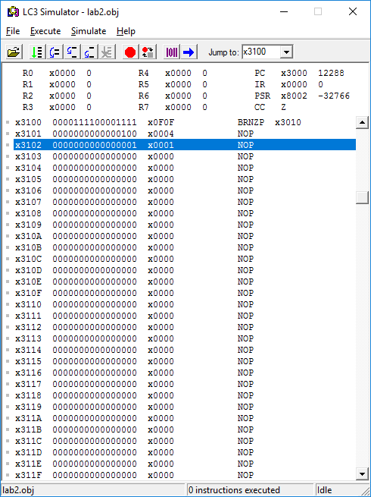
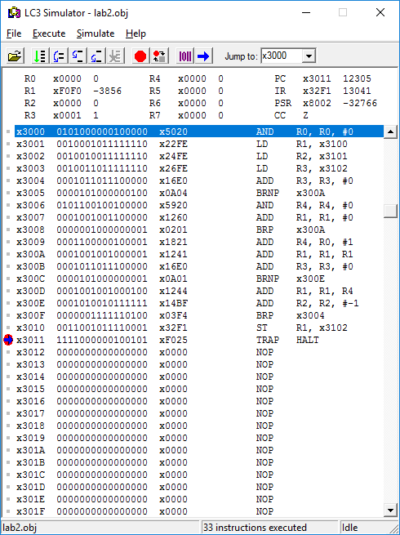
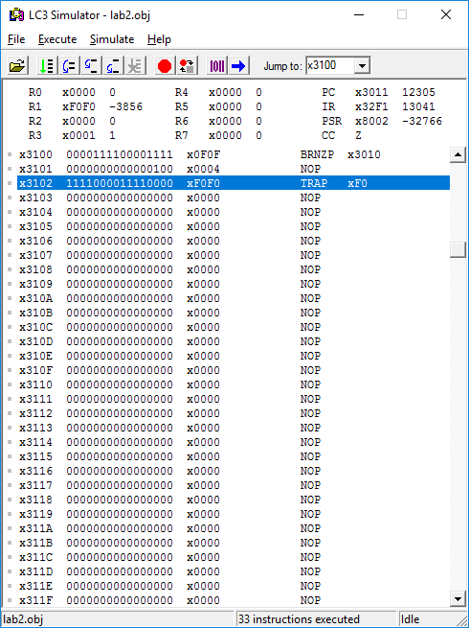

Assembly Language – Lab 2

.ORIG x3000
AND R0, R0, #0 ;Clear R0 to be used as a constant
LD R1, x0FE ;Load bit pattern into R1
LD R2, x0FE ;Load n (number of times to shift/rotate)
LD R3, x0FE ;Load the switch (will decide whether to Shift/Rotate; if 0, it will shift, if not 0, it will rotate)
ADD R3, R3, #0 ;Flag setup
BRnp #4
AND R4, R4, #0
ADD R1, R1, #0
BRp #1
ADD R4, R0, #1
ADD R1, R1, R1
ADD R3, R3, #0
BRnp #1
ADD R1, R1, R4
ADD R2, R2, #-1
BRp #-12
ST R1, x0F1
HALT
.END

Machine Language – Lab 2

0011000000000000
0101000000100000
0010001011111110
0010010011111110
0010011011111110
0001011011100000
0000101000000100
0101100100100000
0001001001100000
0000001000000001
0001100000100001
0001001001000001
0001011011100000
0000101000000001
0001001001000100
0001010010111111
0000001111110100
0011001011110001
1111000000100101

